Retail Sales Dashboard Report

1. Introduction
The Retail Sales Dashboard provides a comprehensive visual overview of retail business performance, key financial metrics, and operational distribution across various categories, store types, and locations.

2. Objectives
- Monitor Core Performance: Track key financial metrics including total revenue, total profit, total orders, and total quantity sold.
- Analyze Category Distribution: Evaluate revenue and profit performance across diverse product categories.
- Evaluate Temporal & Format Trends: Track operational performance across consecutive years and varied store types.
- Track Store Performance: Deliver granular, store-level analytics via structured tabular visual layouts equipped with trend indicators.

3. Dataset Description
The underlying dataset tracks enterprise retail sales performance across multiple structural dimensions:

- Transactional Metrics: Orders, quantities, revenue, and profit values.
- Dimensional Attributes: Product categories, store names, store types, operational years, customer segments, and geographic states.

4. Data Preparation
- Multi-Dimensional Filtering: Configured dedicated interaction paths via dynamic slicers for Category, Store Name, Year, Customer Segment, and State.
- Metric Aggregations: Explicit dynamic aggregation pipelines established to compute overarching business metrics dynamically across applied filter contexts.

5. DAX Measures Used
Measure Name | Description
Total Revenue | TOTAL REVENUE = SUM('Fact_Sales'[total_amount])
Total Profit | TOTAL PROFIT = SUM('Fact_Sales'[profit_amount])
Total Order | TOTAL ORDER = DISTINCTCOUNT('Fact_Sales'[order_id])
Total Quantity | TOTAL QUANTITY = SUM('Fact_Sales'[quantity])

6. Dashboard Components

Key Performance Indicators (KPI Cards)
High-level summary cards displaying core aggregate results:

- Total Revenue: $4.707B
- Total Profit: $979.89M
- Total Orders: 15K
- Total Quantity: 112K

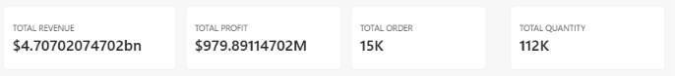

Visual Breakdown Elements
- Bar Chart (Total Revenue by Category): Illustrates revenue distribution across categories including Accessories, Audio, Home Appliances, Laptops, Mobile Phones, Televisions, and Wearables.
- Line Chart (Total Revenue by Year): Visualizes historical revenue progression and trends across 2024, 2025, and 2026.
- Treemap (Total Profit by Category): Highlights category profit contributions, emphasizing top drivers such as Mobile Phones and Laptops.
- Donut Chart (Total Revenue by Store Type): Breaks down performance across operational channels, showing Online sales leading at $3.25B (69.02%), followed by Urban, Flagship, Mall, and Suburban locations.
- Store Performance Table: Displays granular store metrics (e.g., Online Store, Mumbai Inorbit Mall, Bengaluru Orion Flagship) featuring individual revenue, profit totals, and dynamic time-series trendlines.

7. Slicers & Filtering Configuration
- Category Slicer: Positioned in the top right header region for category-level domain filtering.
- Store Name Slicer: Positioned in the top right header region for specific store isolation.
- Year Slicer: Positioned on the right navigation panel for temporal filtering across historical periods.
- Customer Segment Slicer: Positioned on the right navigation panel to segment by customer demographic profiles.
- States Slicer: Positioned on the right navigation panel for regional and geographic filtering.

8. Key Findings
- Revenue & Profitability: Total Revenue reached $4.71 billion, yielding a total profit of $979.89 million.
- Operational Volume: Transaction volume totaled 15K orders, representing 112K units sold.
- Channel Dominance: Digital channels heavily dominate operations, with Online Stores generating $3.25 billion (69.02%) of overall revenue.
- Product Leadership: The Mobile Phones and Laptops product categories account for the largest revenue and profit shares across the business.
- Top Performing Outlets: Prominent revenue-generating locations include the Online Store, Mumbai Inorbit Mall, and Bengaluru Orion Flagship.

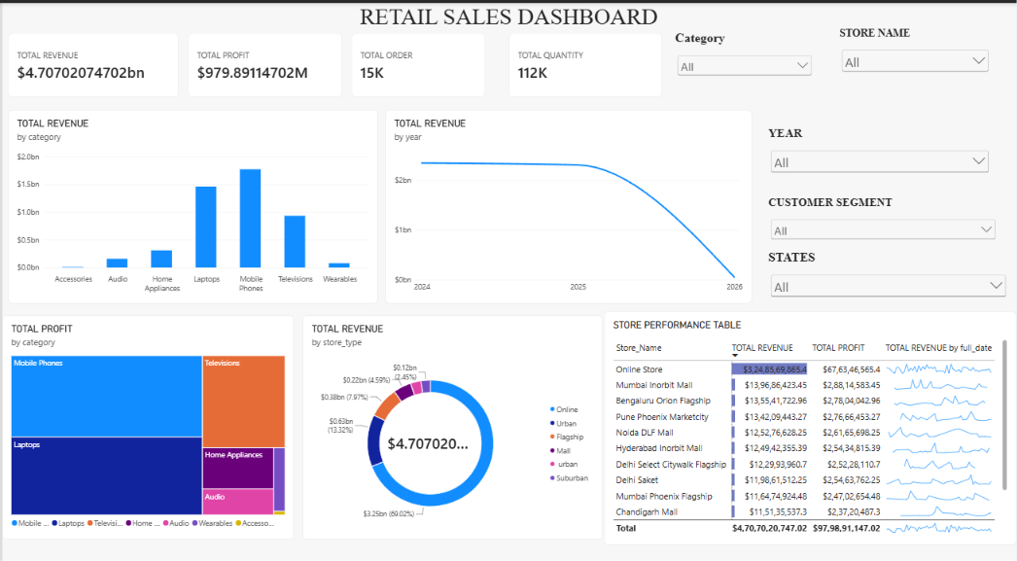

9. Conclusion
The Retail Sales Dashboard establishes an effective visual analytics frame for enterprise operations. By organizing strategic financial metrics, operational channels, and localized store data into an integrated layout, the dashboard equips decision-makers to effectively identify growth drivers, evaluate store efficiency, and optimize retail strategy.

